[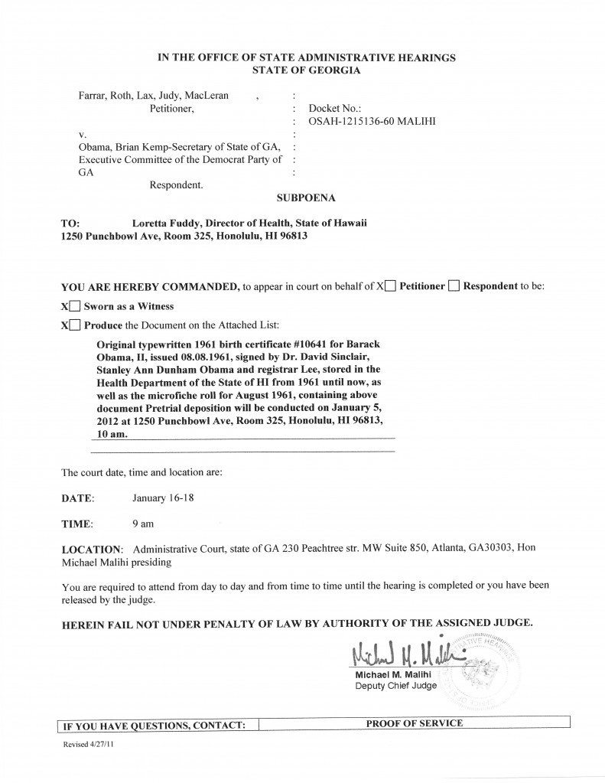](http://www.orlytaitzesq.com/?attachment_id=28906)