DR. ORLY TAITZ, ESQ
PRESIDENT
DEFEND OUR FREEDOMS FOUNDATION
MEMBER INERNATIONAL CRIMINAL BAR PANEL
29839 SANTA MARGARITA STE 100
RANCHO SANTA MARGARITA, CA 92688
PH. 949-683-5411 FAX 949-766-7603
ORLY.TAITZ@HUSHMAIL.COM
ORLYTAITZESQ.COM

YOUR EXCELLENCY, SANG HUYN-SONG
PRESIDENT
INTERNATIONAL CRIMINAL COURT;
FATOU B. BENSOUDA,
ICC CHIEF PROSECUTOR
MAANWEG 174 2516 AB
THE HAGUE
THE NETHERLANDS;
LAURA VERICAT FIGAROLA
LAURAVERICAT@BPI-ICB.COM
ADDENDUM
to
CIMINAL COMPLAINT AGAINST KHALID MESHAAL,
LEADER OF TERRORIST ORGANIZATION HAMAS,
FOR GENOCIDE AND CRIMES AGAINST HUMANITY
JURISDICTION

ADMISSION BY THE PALESTINIAN UN REPRESENTATIVE, UNITY GOVERNMENT PARTNER OF THE TERRORIST ORGANIZATION HAMAS, THAT SENDING EACH ONE OF THE 2,600 ROCKETS BY HAMAS INTO THE CIVILIAN POPULATION OF ISRAEL, REPRESENTS A CRIME AGAINST HUMANITY REGARDLESS OF WHETHER THE MISSILES HIT OR MISS, AS THE MISSILES ARE DIRECTED AT CIVILIAN POPULATION
Today Palestinian Authority, Unity Government Partner of the Terrorist Organization Hamas, announced that it decided to sign the Rome statute of the International Criminal Court.
Palestinian envoy to the United Nations Ibrahim Kraishi said the “Palestinian weakness” in terms of international law is the indiscriminate firing of rockets at Israel.
“The missiles that are now being launched against Israel, each and every missile constitutes a crime against humanity, whether it hits or misses, because it is directed at civilian targets,” Kraishi told Palestinian Authority TV, in a clip distributed and translated by watchdog group MEMRI.
This statement by the Palestinian Representative to the UN represents an admission against the interests, which is admissible by the ICC in prosecution of Khaled Meshaal, leader of Hamas.
Plaintiff Orly Taitz respectfully requests ICC to add aforementioned admission to the complaint against Khaled Meshaal for Genocide and Crimes against Humanity submitted by the plaintiff to the ICC on 07.30.2014
Signed
/s/ Dr. Orly Taitz, ESQ

PA to sign Rome Statute of ICC

Palestinians could sue Israel for ‘war crimes’ but exposing themselves to similar allegations
BY TIMES OF ISRAEL STAFF AND RAPHAEL AHREN July 31, 2014, 6:37 am 14
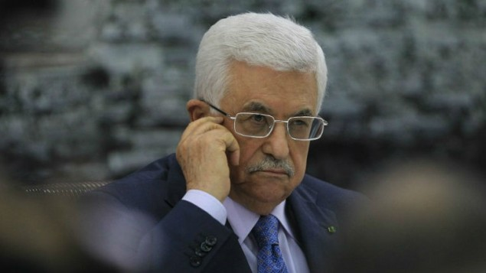
Palestinian Authority President Mahmoud Abbas looks on as he meets with members of the Palestine Liberation Organization (PLO) on July 22, 2014, in the West Bank city of Ramallah. (photo credit: AFP/ABBAS MOMANI)

WRITERS
Raphael AhrenRaphael Ahren is the diplomatic correspondent at The Times of Israel.
- Follow or contact:
- Facebook
- Twitter
- Email
- RSS

NEWSROOM
- Email the Newsroom
- Facebook
- Twitter

RELATED TOPICS
- ICC INTERNATIONAL CRIMINAL COURT
- OPERATION PROTECTIVE EDGE
- GAZA STRIP
The Palestinian Authority decided Wednesday night to accede to the Rome Statute of the International Criminal Court, as a first step to joining the International Criminal Court (ICC).
Get The Times of Israel's Daily Edition by email
and never miss our top stories FREE SIGN UP!
Sources in Ramallah told Army Radio that the Palestinian Authority was waiting for legal opinion after which it would join the 139 countries that are signatories to the statute
The move would allow the Palestinian Authority to file suit against Israel for “war crimes” during Operation Protective Edge, as it has repeatedly threatened to do, but it would also be exposing itself to similar allegations.
Earlier this month, a senior Palestine Liberation Organization warned that the Palestinians were ready to join the ICC “sooner rather than later.”
“We have a decision to accede to the Rome Statute,” PLO executive committee member Hanan Ashrawi told The Times of Israel. “All we need to do is send the letter… If this assault continues and doesn’t stop, you can see it sooner rather than later.”
Ashrawi refused at the time to say when exactly the Palestinians leadership would submit the application, a move that would greatly anger Jerusalem and probably be met with harsh retaliatory measures.
“Actually, we’re trying to do things in an incremental way at this point. We are working on the legal aspects of cases and lawsuits, and so on,” Ashrawi said. “We gauge things as we go along.” Ramallah is unafraid of Israel countersuing Palestinians, she asserted, refusing to state whether she considers indiscriminate rocket fire on Israeli cities a war crime.
Earlier this month, Palestinian envoy to the United Nations Ibrahim Kraishi said the “Palestinian weakness” in terms of international law is the indiscriminate firing of rockets at Israel.
“The missiles that are now being launched against Israel, each and every missile constitutes a crime against humanity, whether it hits or misses, because it is directed at civilian targets,” Kraishi told Palestinian Authority TV, in a clip distributed and translated by watchdog group MEMRI.
http://www.timesofisrael.com/pa-to-sign-rome-statute-of-international-criminal-court/

